Numbers of Library books / journals / periodicals subscribed

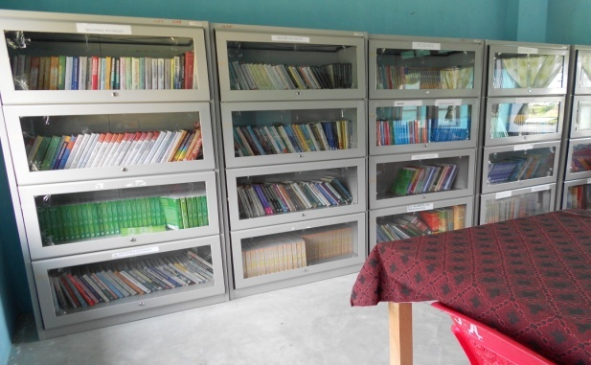
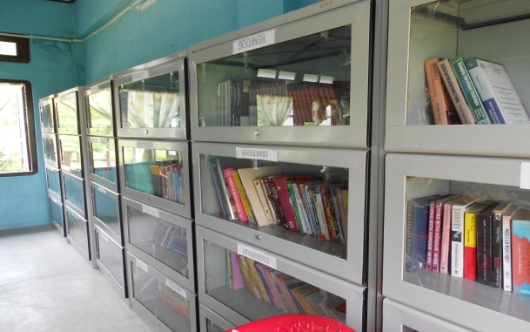

Sl | PARTICULARS | QUANTITY
1 | No.of books | 3120 nos.
2 | No. of Educational Journals & Periodicals | 31 nos.
3 | No. of Reference Books | 135 nos.
4 | No. of Encyclopedias | 58 nos.

